# MGMT 443 Eager Sellers and Stony Buyers: Understanding the Psychology of New-Product Adoption

* In today’s hypercompetitive marketplace, companies that successfully introduce new products are more likely to flourish than those that don’t
* New products fail at the stunning rate of between 40% and 90%
* 47% of first movers have failed
  + Approximately half the companies that pioneered new product categories later pulled out of those business
* New products often require consumers to change their behaviour
  + Those behaviour changes entail costs
  + Consumers incur transaction costs
  + Bearing learning cost
  + People sustain obsolescence costs
* Many companies ignore psychological costs associated with behaviour change

## The psychology of gains and losses

* Companies have long assumed that people will adopt new products that deliver more value or utility than existing ones
* Relative advantage
  + Most critical driver of new product innovations and of consumers
  + Assume that companies make unbiased assessments of innovations and consumers’ likelihood of adopting them
  + However, it fails to capture the psychological biases that affect decision making

### Gains and Losses

* Human beings’ responses to the alternatives before them have four distinct characteristics
  + People evaluate the attractiveness of an alternative based not on objective, or actual, value but on its subjective, or perceived , value
  + Consumers evaluate new products or investments relative to a reference point, usually the products they already own or consume
  + People view any improvements relative to this reference point gains and treat all shortcomings as losses
  + Losses have a far greater impact on people than similarly sized gains
    - Most important effect
    - A phenomenon that Kahneman and Tversky called “loss aversion”

### The endowment effect

* Loss aversion leads people to value products that already possess more than those they don’t have
* Endowment effect
  + consumers value what they own, but may have to give up, much more than they value what they don’t own but could obtain

### Status quo bias

* status quo bias
  + the existence of the status quo bias in people’s choices relating to investments, automobiles, and jobs
* status quo bias intensifies over time
* most people seem oblivious to the existence of the behaviors implicit in the endowment effect and the status quo bias

## Building a behavioural framework

* A behavioral framework around the three entities that drive the market potential of any innovation: the new product or technology itself, the consumer who must adopt it, and the company that designs it.

### Innovations and behaviour change

* The successful adoption of an innovation often involves trade-offs
* While consumers may obtain highly desirable new features by buying an innovation, they often must give up some of the benefits of the incumbent product
  + Consumers rarely view these trade-offs as simple behavior changes
  + they see them as gains and losses
    - Provide a consumer with a new benefit, and she will see it as a gain
    - Take away a benefit, and she will see it as a loss

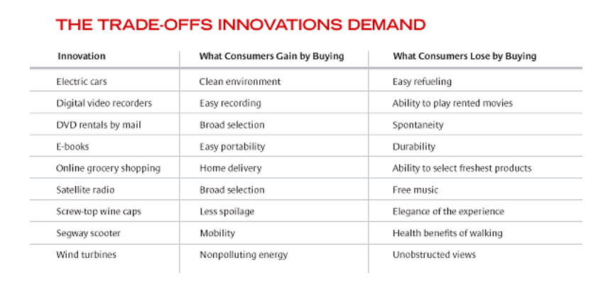

### Consumers and behavioural change

* Consumers view products they own or use regularly as part of their endowment
  + they assess innovations in terms of what they gain and lose relative to those existing products
* consumers overvalue losses by a factor of roughly three
  + It’s not enough for a new product simply to be better. Unless the gains far outweigh the losses, consumers will not adopt it.

### Companies and behaviour change

* companies would know that consumers irrationally overvalue incumbent products and would take that bias into account when launching innovations
  + But executives are also biased—in favor of new products
* Several problems arise when executives’ reference points shift, and they adopt the innovation-as-status-quo perspective
  + They fall victim to the endowment effect just as consumers do
  + overvalue the benefits of their innovations by a factor of three
* executives are also unaware of their bias
* Due to the “curse of knowledge
  + Developers expect consumers to see the same value in their innovations that they see. As a result, instead of anticipating difficult sells, managers are shocked when sales don’t materialize

## Balancing product and behaviour changes

* What can companies do to ensure that consumers will adopt new products?
  + ask what kind of change they are demanding of consumers
  + Innovations create value for consumers through product changes
  + Comparing product and behavior change yields a certain tension
    - Companies create value through product change, but they capture that value best by minimizing behavior change.

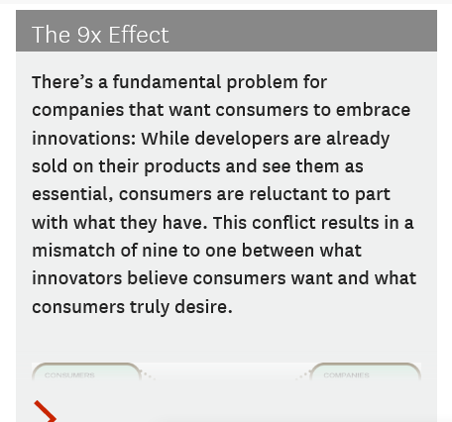

### Easy sells

* The most common new products are those that entail limited changes and require limited adjustments in behavior
* Consumer acceptance of such products may be quite high, but the benefits to both consumers and companies are limited.

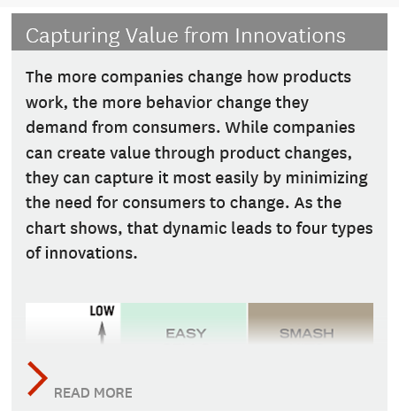

### Sure Failures

* Companies should avoid developing products that involve limited change and offer few benefits but require significant behavior change

### Long hauls

* Many new products offer technological leaps, creating great value.
  + However, they also require significant behavior change

### Smash hits

* Some innovations offer great benefits but require minimal behavior change
* These products stand the best chance of both short-term and long-term success

## Accepting Resistance

* companies can do several things to manage consumer resistance

### Be patient

* The simplest strategy for dealing with consumer resistance is to brace for slow adoption.
* To be successful, companies must anticipate a long, drawn-out adoption process and manage it accordingly
* When companies wrongly assume that the adoption of new products will be rapid, they run the risk of depleting their resources too quickly

### Strive for 10x improvement

* Another approach to managing customer resistance is for companies to make the relative benefits of their innovations so great that they overcome the consumer’s overweighting of potential losses

### Eliminate the old

* When facing unavoidable consumer resistance, a company can eliminate incumbent products
* Most companies don’t have the option of eliminating rivals
  + However, in some cases, regulatory agencies can play a facilitating role

## Minimizing Resistance

* For many companies, the long-haul option is unattractive, innovations that offer 10x improvements are rare, and eliminating the old is impossible. These companies must minimize consumer resistance.

### Make behaviourally compatible products

* Companies can reduce or eliminate the behavior change that innovations require and thereby create smash hits

### Seek out the unendowed

* A company can also seek out consumers who are not yet users of incumbent products

### Find believers

* Another option is for a company to seek out consumers who prize the benefits they could gain from a new product or only lightly value those they would have to give up
* All too often, consumers fail to buy products that companies expect them to adopt
* The reason may lie less in the economic value of physical products and more in the minds of people
* Until businesses understand, anticipate, and respond to the psychological biases that both consumers and executives bring to decision making, new products will continue to fail